Immediate Software



IMMEDIATE Software für Marketing und Media GmbH

Kleiner Ort 1
28357 Bremen, Germany
Phone: +49.421.2071500
Fax: +49.421.2071330
Email: info@immediate.de

Contents

The workspace 2
Finder 3
Codesheet 3
Media 4
Characteristics 5
Language selection 5
Selecting and deleting 6
The toolbar 7
Loading and saving 7
Layout 10
Excel – CSV 10
Tabulation 10
Changing the order of table columns/table rows 12
Table filters 12
Sorting columns 13
Linked target groups 13
Changing the target group name 15
Media in the Tabulation 16
Table layout 17
Counting media overlaps 22
Generator 24
Time series 25
StoryFinder 26
Ranking 27
Basic conditions for media 28
Tariffs 28
Circulation 31
Target group 33
Media selection 33
Definition of media combinations for any media item in a type 34
Own media – saving media lists 35
Editing media-related presets 35
Selecting characteristics 36
Sorting the ranking 45
Displaying results in millions/thousands 45
Batch ranking counts 46
Media plan 47
Assign plan 47
Selecting characteristics 50
"Characteristics" folder 50
Layout of media plan reports 52
Price optimisation on/off 54
Masterplan – automatic plan optimisation 56
The time dimension 58
Plan analysis 64
Exposure distribution 65
MediaMix 66
Segmentation 67
Charts: producing graphical reports 68
Target group 74
Index 89

M-Cloud
 WYSIWYG interface
On-screen results are updated immediately after you make your changes.
Clear, easy-to-use layout of reporting modules
Any kind of report can be created using a total of just 3 workspaces.
All settings and definitions are entered directly within the workspace.
Drag & Drop
Tables, rankings and media plans are defined on the report screen itself.
Automatic filters
Groups of questions queried under "Filters" are now not only expressed as percentages of the table base (as before) but also of the filter variables.
Minimal resource requirements
All analyses, whatever their scope, require just a web browser and appropriate user rights.
We carry out software questionnaire data updates ourselves, using a platform-independent, up-to-date and flexible approach based on centralised data storage and software management.
An SLA for your peace of mind
We guarantee 24/7 availability for both software and questionnaire data. Data security is ensured by using individual, password-protected customer accounts.
Historical data
Questionnaire, tariff and circulation files are available for all years as far back as 1990.

The workspace
Rankings, media plans, tabulations: you create your counts on a total of just 3 codesheets.
All settings and definitions are configured/entered directly into the report in question.

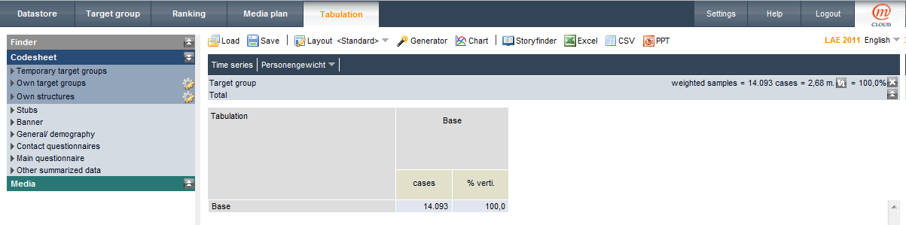
The workspace is divided into two areas: The left-hand area contains:
- Finder
- Codesheet
- Media
- Characteristics

In the upper right-hand panel, details of the currently-active filter target group and current questionnaire are displayed. The body of table data – tabulation or media analysis – is laid out below this.

Finder

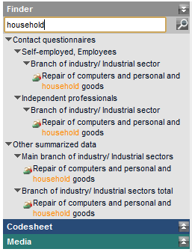 | You can search the Codesheet and Media folders for the specified character string by pressing [Enter] or clicking the magnifying glass icon.  The results of the search are presented in a list underneath the input box.  - Individual target groups from the Codesheet or media from the Media folder can be inserted directly into the report  Or  - You can [Ctrl]-click to jump to the item in the Codesheet.  Note that you cannot drag entire attributes (marked by the icon) into the report directly from the Finder.

Codesheet

Target group selections on the Codesheet are made hierarchically. The first level provides a rough categorisation of the information available. As a rule, the second level presents the attributes surveyed (i.e. questions asked) by the questionnaire. The last level is indicated by the icon.
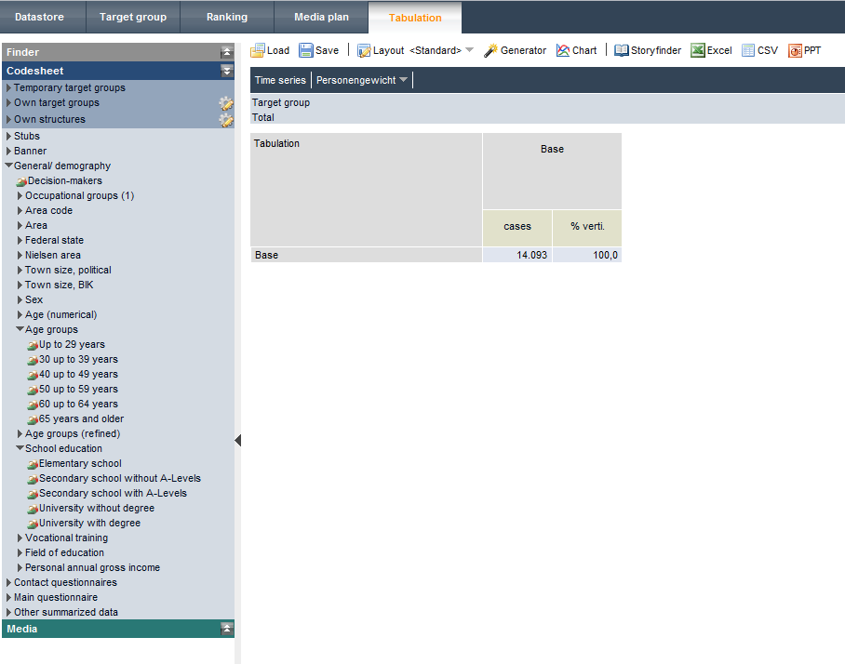
The arrow indicates a closed folder; the arrow indicates an open folder.
"Temporary target groups" folder
Target groups defined in the "Target Groups" program module are stored on the Codesheet under the item "Temporary target groups". Where target groups have been combined, the complete definition is visible with all sub-target groups, so that not only the linked, complete target group but also partial target groups can be imported into the report table. Assuming you do not exit from the program, you can insert target groups from this folder into any report.
"Own target groups/Own structures" folders
Stored column and row definitions are displayed at the top of the Codesheet in the folders "Own target groups" / "Own structures", underneath the temporary target group folder.
Folders are managed using the icon.

Media

Media values such as ME or AE are inserted into the table from the "Media" folder.
You can use the (information) icon to display the tariff combinations applicable to a single medium or – for media combinations – the media title used to describe the marked combination. The make-up of the combination is determined from details in the current dataset.
If the members of a tariff combination change over time but the title stays the same, then the members will be shown as applicable to the selected questionnaire – and not the most recent combination.

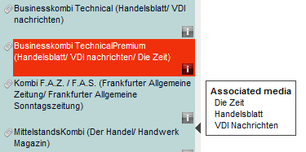 | 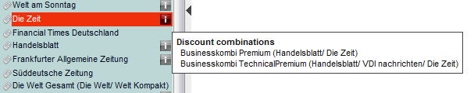

Characteristics

The "Characteristics" folder contains all of the datapoints required for the creation of rankings. You use drag & drop to insert the selected values into the desired position in the ranking. Characteristics such as "Costs EUR" and "Format" can be edited directly in the ranking table. The selection "Layout" from the toolbar can be used to store different combinations of characteristics as default values. The characteristics listed on the "Media plan" provide information that is useful for the creation of media plans. The media plan parameters are specified using the Layout.

Language selection

You can select either the English or French version of M-Cloud when starting the program.
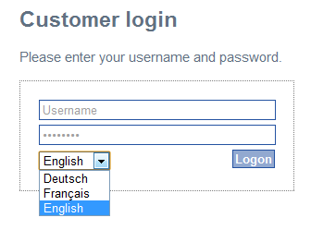

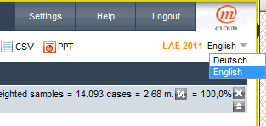 | If the questionnaire loaded is available in two languages, you can switch between questionnaire text and characteristic languages while creating the report. The program language stays set to German.

Selecting and deleting

Selecting
Single codepoints/single attributes | Mouse left-click
Single or multiple attributes | [CTRL] + mouse left-click
Select an area within an attribute | Select top code  [SHIFT] + mouse-click lower point
Cancel all selections made | [ESC]

Deleting
Deleting a row from the table | Mouse right-click – "Delete"  Or  Select + [Del]
Deleting attributes from the table | Mouse right-click attribute header – "Delete arrangement"  Or  [CTRL] + mouse right-click + [Del]
Delete entire table  Delete pre-column  Delete table head  Reset table filter to "All" | Mouse right-click table field "Tabulation" – "Delete table"  – "Delete rows"  – "Delete columns"  Click the cross in the "Target group" row

The toolbar

Loading and saving

The results from the Tabulation, Ranking and Media plan are saved and loaded using the corresponding toolbar icons.
Single definitions such as column structures and media lists are stored using the "Tabulation" or "Media" field. Any table row or table column can be stored as a target group by using the mouse right-click context menu.

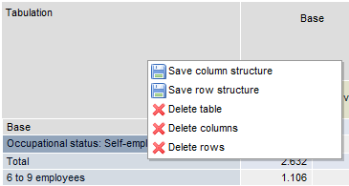 | 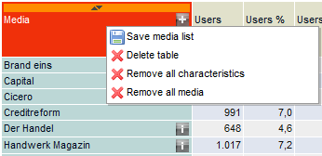

The Save button opens a window for saving your definition.
The left window contains the directory structure, while the saved definitions are stored on the right. The filename for the file to be saved is entered in the bottom row on the right. The default filename for target groups is the title row.
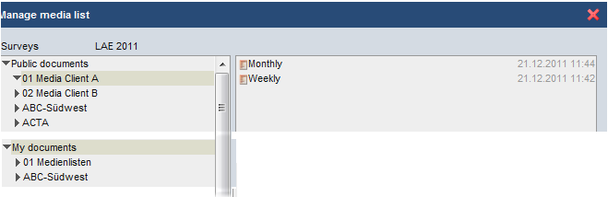

Two directory trees with an identical structure are available: 1. Public documents, 2. My documents.
The structures stored under "Public documents" are available to all users within the company.
Under "My documents", however, you can store files to which you alone will have access (via your user account).
The default location for saving (identifiable by the asterisk) is set to the "Public documents" folder in the directory of the opened questionnaire.
New folders can also be created. In the example, the directories "01 Media Client A" and "02 Media Client B" have been inserted.
Copying files [CTRL] + drag & drop to copy to the target folder
Moving files Use drag & drop to move to the target folder
Any media lists saved can be utilised in other questionnaires. To be able to access a directory from within a report, you need to use the right mouse button to define the directory as a Standard directory. You will then be able to access the saved files from "My documents".
Structures saved from the Codesheet can be loaded into other years from the same questionnaire. For example: you can load structures created in "ma Presse 2010-1" into "ma Presse 2011-2".
The following operations are possible using the right-click context menu:
Directory structure  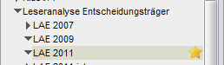 |  | Directory inbox  The directory serves as a mailbox for sent files. From here, files can then be relocated to any other directory.  Standard directory  Any directory can be defined as the Standard directory. This directory is marked with an asterisk to indicate that it is the default save location.
Stored definition  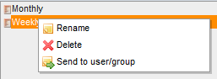 |  | Once saved, files can be sent to other users:  the file is then stored in the Inbox of the addressee specified.
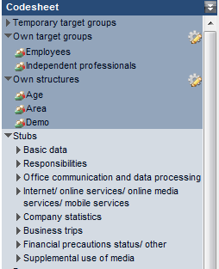  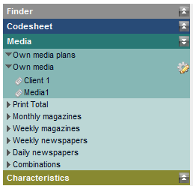 | Stored target group, column and row definitions are displayed at the top of the Codesheet in the folders  Own target groups  Own structures  underneath the temporary target group folder.  Saved media lists are displayed in the Media folder under Own media, underneath the media plans that are temporarily available.

The temporary directories Temporary target groups and Own media plans are available only while the application remains open.

Layout

On the layout input screen, a range of layout profiles can be created, which can then be accessed for use in various reports.
Using the drop-down menu on the right of the "Layout" button, choose a profile that is then applied to change the table layout. When the program starts, the table layout defined as Standard is loaded.

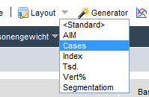

Excel – CSV

The results produced by the reports can be output as an Excel or CSV file (unformatted).

Tabulation
Tables are defined on the report screen itself. As you work on the table worksheet, you fill it, one by one, with your target groups.
On the status bar, a range of choices are offered, depending on availability:
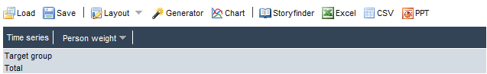

Time series: | Opens a window for selecting the available questionnaires used for calculating time series
Person weighting: | If the selected questionnaire contains more than one weighting, you can use this drop-down menu to change the weighting for the report.

If the questionnaire is available in multiple languages, you can change the language for the Codesheet and Layout. Program text remains shown in German. It is not necessary to configure the setting before creating a report. You can, for example, prepare your report in German and then switch over to English before outputting the results to Excel.
The right-hand window provides the working area in which the corresponding report is defined and updated in real time. Using drag-and-drop, you drag your target groups directly from the questionnaire's Codesheet to the desired position in the table: as the table base, as a target group in the pre-column or as a target group in the table head.
As soon as you drag a structure/target group to the right-hand work area, the areas in which target groups can be placed are highlighted in green.
You can insert individual codepoints, individual attributes or complete structures into the table. Multiple target groups or attributes can be inserted into the table in one operation, by selecting them beforehand.
Attributes are always added to the end of the table. After adding, however, the order of the attributes can be changed.
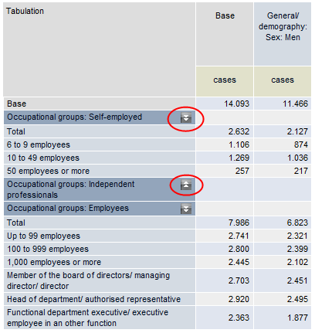

By left clicking with the mouse on an attribute header, you can hide the attribute's characteristics. This is indicated by the arrow icon next to the heading. If you click again on the heading, the characteristics are shown once more.

Changing the order of table columns/table rows

Changing the order in the pre-column
Right-click the attribute header to access the context menu.

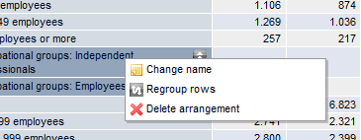

The selection Regroup rows opens a window containing all attributes in the pre-column.
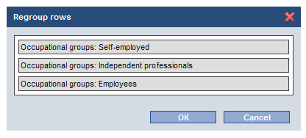

Using the left mouse button, you can now click any header row and drag it to the desired position. Once you confirm the new sequence with "OK", the attributes are then rearranged in the table.
Changing the order in the table head
Table columns are resorted using drag-and-drop.

Table filters

A special rule applies when defining the table filter: combined target groups can be defined as a table filter directly from the Codesheet.
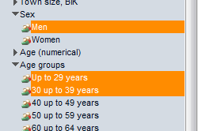 | To do so, select your chosen target groups and drag these together into the table filter. A single attribute's target groups are linked with "OR"; target groups from different attributes are linked with "AND".  The filter target group cannot be subsequently extended or edited.  The target group is reset to All by clicking the icon in the table filter.

Linked target groups, which cannot be created using the typical linking logic, must be defined using the Target group menu item.

The icon can be used to switch between showing the projected total in thousands or millions.

Sorting columns

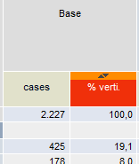 | You can sort the table in ascending or descending order by clicking the arrow in the column header above the characteristic.

Linked target groups

Combinations of target groups are simple to make, both in the table rows and column headers of the table.

Method 1 – Simple link
Mark the rows that are to be linked and then use the mouse's right-click context menu to select your chosen operator.
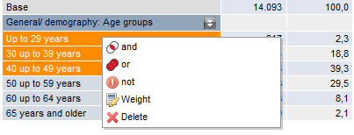
The new, linked target group replaces the individual target groups.
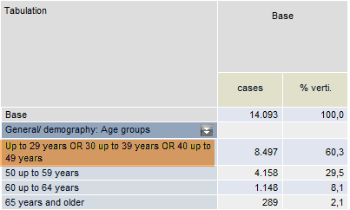

Where target groups are linked from different attributes, the marked codes are removed from the attribute and inserted into the table under a new heading.

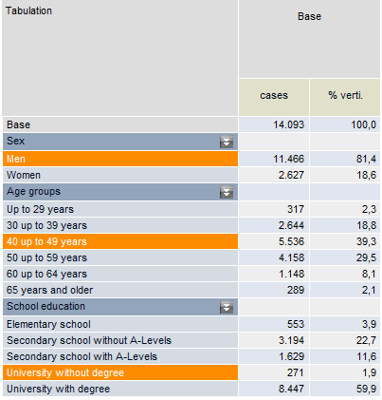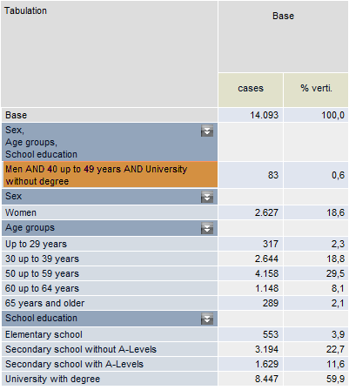
Linking three target groups

Method 2 – Target group editing
To modify a target group in the table, select Edit from the right-click context menu.
In editing mode, the target group is displayed in detail with all available linking operators. The potential is displayed for each partial target group.
Individual partial target groups can be removed or added from the Codesheet via drag-and-drop.

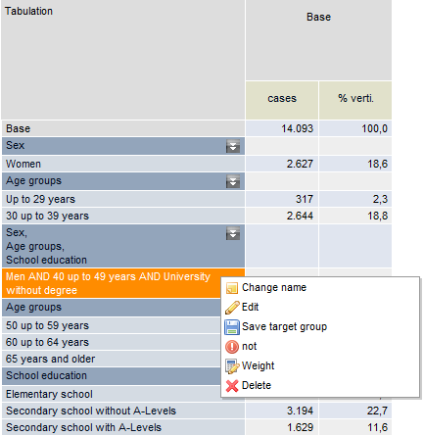 | 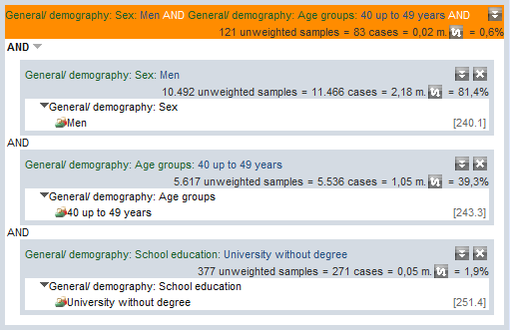
Table view: Men aged between 40 and 49, without a university degree | Edit mode: Men aged between 40 and 49, without a university degree

For information on editing target groups, please consult the Target group chapter.

Changing the target group name

You can use this selection from the right-click context menu to edit the name for the new target group. The text of both headings and individual rows can be changed.

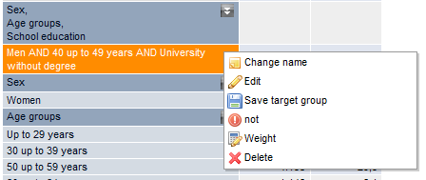

The original text of a linked target group is not lost. You can show the complete target group definition by selecting Edit from the right-click context menu.

Media in the Tabulation

By default, media are inserted into the tabulation with the "currency" ME (media exposure). This is documented in the info bar shown above the table.
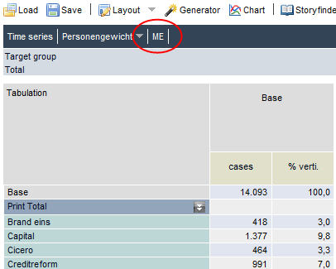

Click the ME button to show a selection window for possible characteristics:

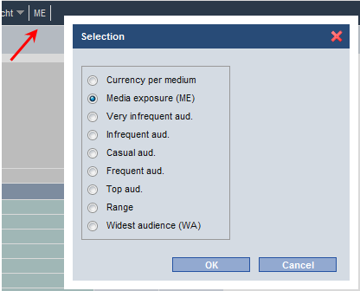

the characteristic selected applies to all media in the table.
The selection Currency per medium can be used to change the characteristic for each individual medium in the table.
Left-clicking the icon opens the media currency selection screen.

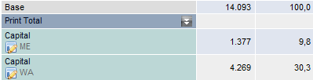

Table layout

You can create a suitable layout for each report type. For example, you can create a layout for default tables and another layout for media plan segmentation.
On the reporting page, you can use the drop-down menu on the right of the "Layout" button to access the list of your stored profiles, in order to change the table layout. When the program starts, the table layout defined as Standard is loaded.

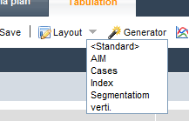

A layout definition covers the presentation rules for the table head, the base column and – if available in the questionnaire – the auto-filter base column.

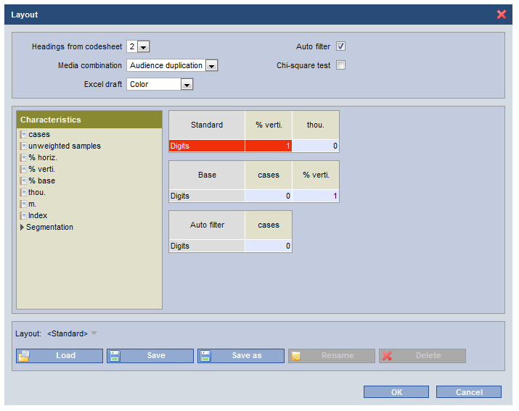

Headings from codesheet
Here, you specify how many levels of the codesheet selection should be used as the heading in the definition.
You can use Edit – Options to change the number of headings for each individual target group in the table at any time.

Media combination
By default, counts for Media vs. Media will use Audience duplication. You can change this setting in the Layout.

Auto filters
For most questionnaires, there are groups of questions that are only partially presented to those surveyed.
If the auto-filter is activated for target groups, then, on the Tabulation, attributes queried under filters are now not only expressed as percentages of the table base (as before), but also of the filter variables. A base row is then shown in the table, on which the following variables are then filtered.
Questionnaires may include questions only for the self-employed or employees, for example. If the auto filter has been activated, the program automatically considers this restriction when calculating percentages.
If you deactivate the auto filter, variable percentages are calculated on the table filter or the first row of the table.
In the example below, the activation of the auto filter means that the attribute filters "Has branch office" and "Management level" are applied only to the "Self-employed" and "Employee" target groups, respectively.

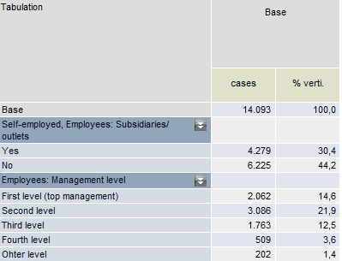 | 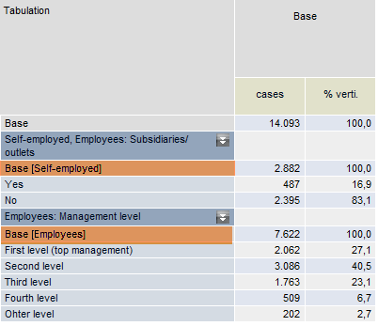
Report counted without auto-filter | Report counted with auto-filter

Chi square test
The chi square test tells us whether or not the deviation of a (partial) target group result from the overall target group's result is significant.
As common in social research, M-Cloud utilises an underlying confidence level of 95%.
The tests offers the assurance that differences in results between a partial target group and the overall target group are in fact within the specified tolerance zone and are not simply random.

Partial target group results are highlighted in colour where these differ significantly from the results of the overall target group and their deviation lies within the permitted range of fluctuation.

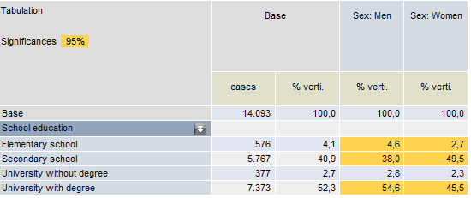
For women, 49.5% attended secondary school without a school leaving certificate. The figure is 40.9% for the overall target group.
With a confidence level of 95%, the error threshold, according to the table, for the range of fluctuation for the target group "Women" is approx. xx%.
At 49.5%, the deviation of the "Women" target group from the overall target group is definitely significant, since it lies outside the spread of possible sampling errors (40.9% - 49.5 % = -8.6%, thus greater than xx%).

Selecting units of measure
A table layout defines the representation of the three table elements standard, base and auto-filter.
- The characteristics configured in the Standard row affect the table columns
- The presentation of the first table column is specified in the Base row.
- The selection of characteristics for the Auto filter is effective for table bases that are automatically inserted into the table, as soon as a filtered variable is inserted into the table head.

Configure the layout of your table by dragging the characteristics to a green field in the column layout.

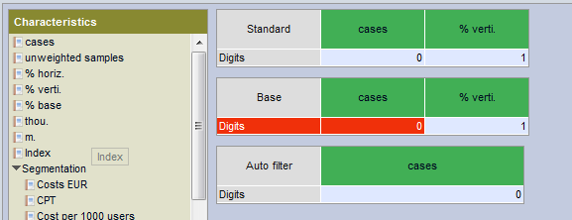

You can use drag-and-drop to change the column order as you wish. Select the number of significant figures for each unit of measure by simply overwriting the preset values.

In the Segmentation folder, characteristics are collected that are relevant only for media exposure types such as LpA and the segmentation of media plans. Predefined format types are used in the rankings for calculating the EUR price per 1,000 users.

Creating a new layout
After combining the characteristics as you wish, choose Save as in order to give the layout a new name. The new layout is then available to you in the Tabulation.

Editing/deleting a saved layout
To edit a layout, choose the layout you want from the Layout list and then click Load.

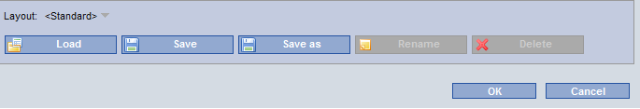

Counting media overlaps

Audience duplication – Exclusive users – External overlapping

In the Tabulation, you count media overlaps automatically if media types (user exposure) are inserted into table rows and table columns.

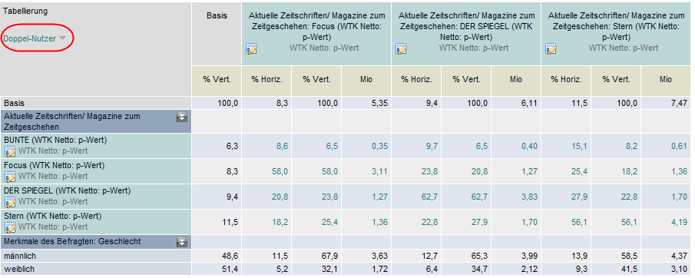

By clicking on Audience duplication in the top left of the table head, you can change the calculation type used for media overlapping. You can switch between Audience duplication, Exclusive users or External overlapping for the media shown at the press of a button.

It is possible to include additional attributes in a table with media overlapping.
You can insert demographic attributes or media user groups – such as "Widest Audience" – into the table.

Areas of media overlapping are highlighted using a green font to distinguish these from the remaining results.

By default, audience duplication is shown. However, you can change this default in the Layout.

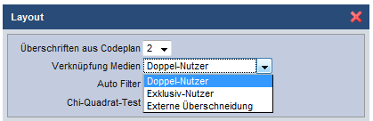

Audience duplication
All of those using the media in the pre-column AND the medium in the header.

Example: "Spiegel" and "Stern" readers
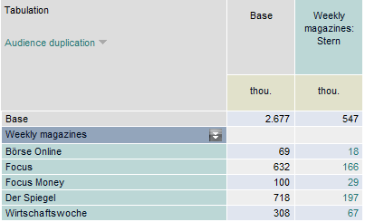

718K respondents read "Spiegel".
197K "Spiegel" readers ALSO read "Stern".

Exclusive users
All of those using the media in the pre-column BUT NOT the media from the header.

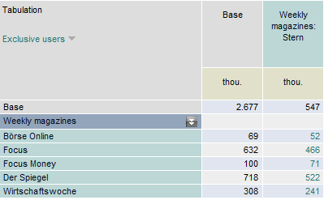
522K "Spiegel" readers DO NOT read "Stern".

External overlapping (2x combo)
All of those who use at least one of the two media ("OR"). This corresponds to the net reach of the two media combined.

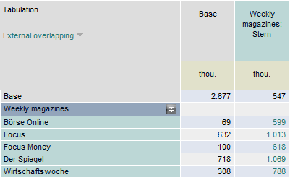
1,069K respondents read at least "Spiegel" or "Stern".

Generator

The Generator serves to automatically link two definitions: all target groups in one definition are linked with all target groups in a second definition. The linking operator can be freely selected. A definition (attribute) can also consist of linked target groups. 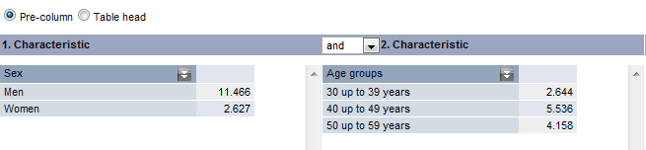
Target group generator
The target groups generated are inserted either into the pre-column or the table head. Make your selection as required. The Add button takes you back to the table view: here, the new table groups will have been added to the end of the table.

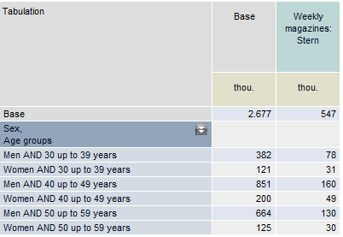

Time series

If multiple years are available for the selected questionnaire, then you can use a time series to report on the results in the Tabulation.
If time series counts are possible, this information is shown in the header: Time series.
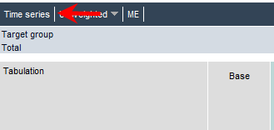

First, create a report, and then click the Time series menu item.
In the selection window, choose the years you require and confirm with [OK].
To calculate price-related characteristics in the time series (e.g. EUR per 1,000 users), you may either use the current tariff file or the tariff file that is valid for the respective questionnaire year.
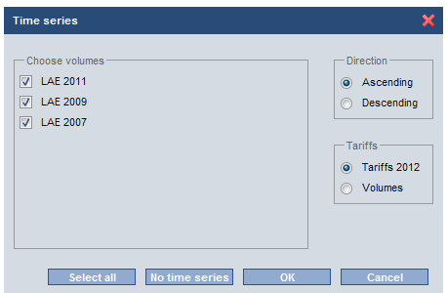

The selections you make are documented in the table head.

To edit the body of the table, it is first necessary to access the original table, make the changes there, and then to access the time series once more.
You exit from the time series by clicking the cross before the selected questionnaire files.

Storyfinder

The Storyfinder feature offers the option of creating a count over all attributes for the selected questionnaire. The output of the table is sent directly to Excel.
Filters and column headers can be chosen freely.
If the count is to be created for multiple target groups simultaneously, you first define the table head. You then click the StoryFinder icon on the toolbar to open the following selection window:
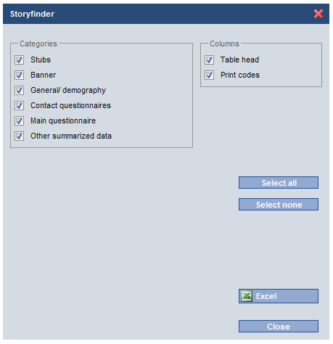 | If the option "Table head" is selected, then the count is generated over the previously-defined table head. Otherwise, the report is generated only using the base column.  The "Print codes" option is used to output the internal code sheet columns to an extra column in the table.  In addition to "Select all" and "Select none", you can click each category to select it for the count.  The output is sent directly to Excel.

Ranking
You can drag media and characteristics from the Media folder and the Characteristics folder directly into the ranking report. The results are calculated immediately.
As you begin a drag operation, the areas in the table with which you can interact are highlighted in colour.
Accordingly, media items can only be dropped into the table body and characteristics into the table head.

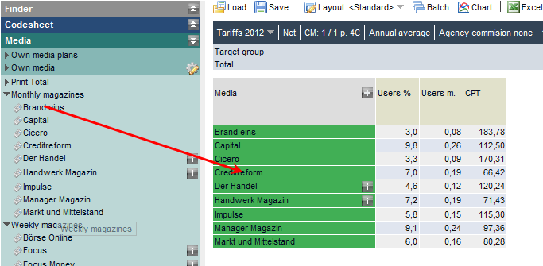

Following a successful drag-and-drop operation, the ranking is dynamically extended by the corresponding attributes. In addition, the order of characteristics can be changed at any time via drag-and-drop.

Basic conditions for media

The general rules for ranking calculation – such as the tariff selection, format and circulation file – are specified and documented in the header rows of the workspace.

The display of the basic configuration is dynamic and depends on media selection and characteristics.
If you select only magazines, then only the format for magazines is displayed.
If the ranking contains the Format characteristic, then the booking/frequency is not displayed on the information bar. The circulation file and circulation type are only available for selection if the characteristic "Circulation" has been inserted into the table. A reference target group is displayed only if "Affinity" is displayed on the ranking sheet.

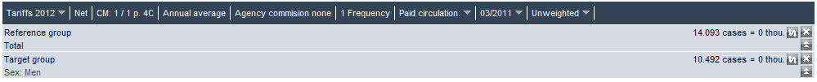

Tariffs

By default, the current tariff files are used for counts. The icon is used to open a drop-down menu for selecting an alternative tariff. Years back as far as 1999 are available.
Gross / Net
Click the menu item to switch between net and gross prices.

Advertisement sizes CM (consumer magazines) – NP (newspapers) – TV (television) – HF (radio)

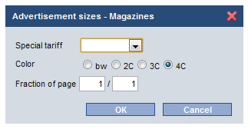 | For magazines, the default format "1/1 p. 4C" is used.  On this screen, you can make a global format change that applies to all media. If the selected default format is not available for a medium, then no price is displayed.
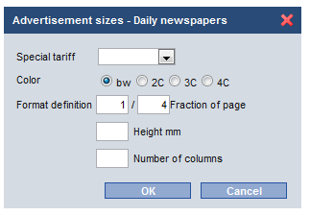 | For newspapers, the format can either be specified in page fractions or in column height plus number of columns on a per-mm basis. In the last case, the price is calculated using the per-mm base price and the page layout.
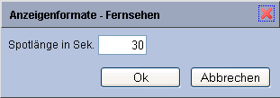 | The basic condition for TV and radio is a spot length of 30 seconds.
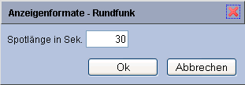

Planning period – annual average
For price calculations, you can choose whether you want to factor in the respective seasonal prices for your campaign period or the average price calculated over the entire year.

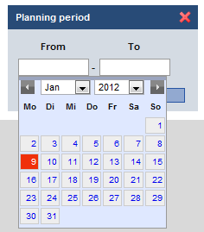 | When you click Annual average, a calendar opens for entering your planning period.  Once this is specified, the seasonal prices valid in this period will be factored in for all calculations – whether ranking or media plan.  The tariff sheet provides information about seasonal prices and price zones. You can access it via the "Format" column in a ranking or media plan.  You can reset the planning period to the annual average by clicking the cross located next to the details of the planning period.

Sample price calculation for Magazine A in the planning period 01/01 – 15/03/07

If one applies the tariff combination "CC Consumer" in the period January 1 to March 15, then three price zones need to be factored in to calculate the price:
Price zone
- 3 for the period January 1 to January 31
- Price zone 1 for February 1 to February 28
- Price zone 2 for the 15 days in March

The planning period covers a total of 74 days.
The weighted price for the planning period is calculated as follows:

28/74 days * € 25,480 + 15/74 days * € 26,499 + 31/74 days * € 24,461 = € 25,260
With more than one booking, the costs for a placement in the planning period are multiplied by the number of bookings. Discounts are factored in as before.

Agency commission
The choice Agency commission none or Agency commission 15% from the status bar can be used to apply an additional discount to media prices.

Booking/frequency
As soon as the characteristic "Frequency" is inserted into the ranking table, the line "Booking/Frequency" is hidden from the header. The predefined number of bookings is copied to the "Frequency" table column for each medium.

Circulation

Multiple circulation types and years for quarterly circulation can now be counted in the ranking simultaneously.
As soon as the characteristic "Circulation" is dropped into the ranking, a selection window appears in which you specify which circulation items are to be displayed in the ranking.

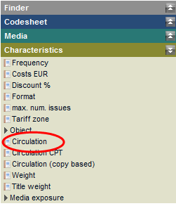 | 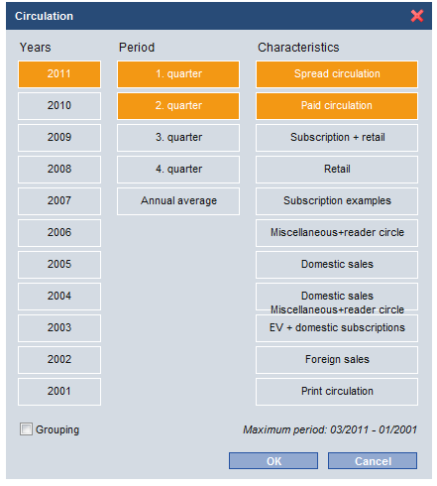

Click to select the quarterly information items you require.
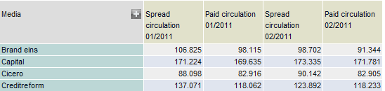

Grouping
If this option is selected, then the characteristics are shown grouped by circulation type.
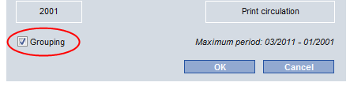

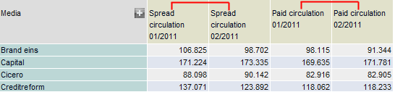

For the characteristic "Circulation" entered into a layout definition, the programme adopts the configuration that was set using the "Characteristics – Circulation" menu.

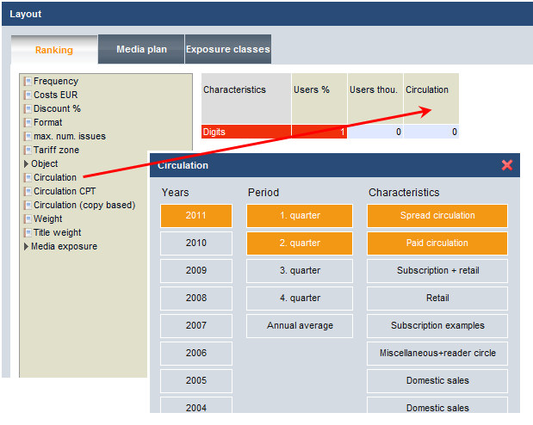

In the media plan analysis, circulation items are selected via the status bar.

Target group

The base target group is inserted directly from the codesheet into the ranking filter. If you drag more than one target group from an attribute into the table filter, the individual codes are linked to a target group using the "OR" operator. Target groups from different attributes are linked with "AND". Select your chosen target groups and drag these together into the filter. The filter target group cannot be subsequently extended or edited. If a complex target group needs to be used, then you should define this using the Target group menu.
The icon can be used to switch between showing the projected total in thousands or millions. This affects the table filter and the display of the users and exposures in the ranking.
The target group is reset to All by clicking the icon in the table filter.
By clicking , you can view the hidden part of the filter target group if the target group text extends over more than one line.

Media selection

Select all the media items you want from the Media folder and use drag-and-drop to move these to the field highlighted in green under "Media".
The icon in the Media field is used to access all of the discount combinations formed by the media items selected. If you click the cross, all of the combinations listed are transferred to the ranking.
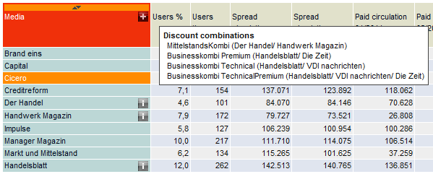

You can use the (information) icon to display the tariff combinations applicable to a single medium or – for media combinations – the media title used to describe the tariff combination. The make-up of the combination is determined from details in the current dataset.

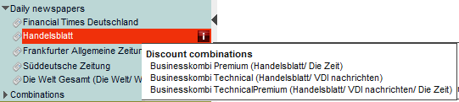
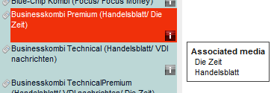
If the members of a combination change over time but the title stays the same, then the members will be shown as applicable to the selected questionnaire – and not the most recent combination.

Definition of media combinations for any media item in a type

You have the option of forming your own media combinations. Select the media items that are to be consolidated into a combination. If you now use the right-click context menu to select "Create media combination", then an input screen is shown in which you can change the default definition given for a media combination. The newly-created combination can be counted in the ranking just as a normal media item. The costs and circulation for the newly-created combination are calculated from the tariffs and circulation for the single media. The calculation process uses the tariffs and circulation type for the basis condition shown on the status bar.

Own media – saving media lists

You can save media lists by using the context menu on the Media table field. These are stored to the folder Media – Own media.
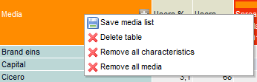 | Other options:  Delete the entire ranking  Delete all characteristics  Delete all media

Stored media lists can be loaded into other questionnaire years or other questionnaires. See also: Using structures and reports across a range of questionnaires.

Editing media-related presets

Presets relating to single media can be configured directly in the workspace.
All ranking columns with editable parameters are highlighted in blue:
- Costs
- Discounts
- Formats
- Frequencies
- Circulation
- Weight

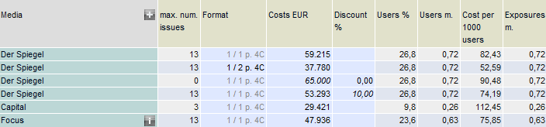

Presets are indicated by the use of italic or bold type. Characteristics affected by the manual presets are updated immediately.
Preset discounts can also be specified for manually-entered costs.

You can use the backspace key | 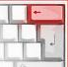 | to reset the preset to the value of the basic condition.

Selecting characteristics

The characteristics can either be inserted into the table from the Characteristics folder under the Media folder or defined via the ranking layout.
The number of significant figures can be changed directly in the ranking table.
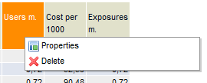 | Right-click context menu:  Properties: Change significant figures  Delete the column

The columns can be resorted at any time.
The media presets made in the ranking are applied to the media plan analysis.

Characteristics folder
The "Characteristics" folder contains all of the datapoints available for the creation of rankings. You use drag & drop to insert the selected values into the desired position in the ranking.

Layout for ranking reports
You can create and save specific ranking layouts for a wide range of reports. The stored definitions can be accessed using the drop-down menu on the right of the "Layout" button.

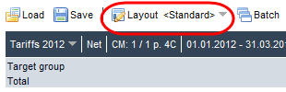

The left-hand window contains all of the datapoints available for the creation of rankings. You use drag & drop to insert the selected values into the desired position in the ranking table. The order can be changed after the values have been added. You specify the number of significant figures for each characteristic by clicking the corresponding field to enter the number, typing a number and confirming your entry with [ENTER].

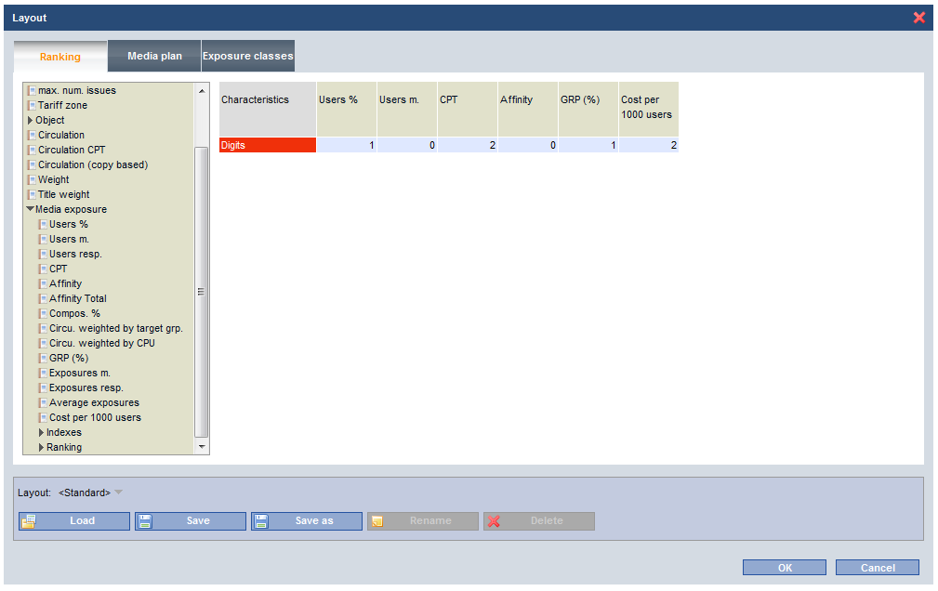
Layout screen "Ranking"

Characteristic definitions

Frequency | Number of bookings (editable)
Costs | Price according to the currently-loaded tariff file, shown using the chosen format (editable)
Discount % | According to the currently-loaded tariff file, shown using the chosen format (editable)
Format | Tariff sheet with price zone information, discount levels  The tariff sheet provides information about the formats stored for this specific medium in the tariff file, including associated gross prices.  A format other than that set by the basic conditions can be chosen by making an appropriate selection.
max. num. issues | Magazines: if a planning period has been specified, the maximum number of possible bookings will be displayed
Price zone | Info about price zones in a fixed campaign period
Object | Media information from the currently-loaded tariff file  Token (for magazines: CM number)  Publisher  Pub. freq. (publication frequency)  Date of pub. (first date sold)  EUR Cover price (single issue price)  Cost sum for single titles  Actual combo costs taken from the tariff file can be compared with the summed costs of the single media.  Unlike the Costs characteristic, which factors in possible discounts, the new characteristic supplies the total of the individual costs calculated via the tariff file.  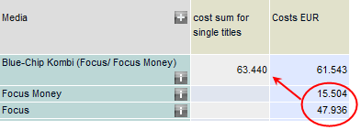  The Blue-Chip combo, consisting of "Focus" and "Focus Money", has a price of € 61,543.00. The cost sum for single titles is € 63,440.00.  For user-defined media combinations, the cost sum always reflects the sum of single title costs.
  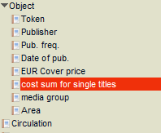
Circulation | See chapter on Circulation
Circulation CPT | 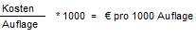  Media plan costs based on circulation, projected to thousands.  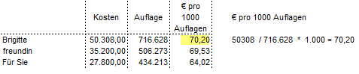
Issue circulation | For issue circulation, the exact circulation figure per issue is reported. If you select multiple weeks for the processing of issue-related circulation, then the average circulation figure is calculated over the selected issues.
Weight | The media weight serves to factor in the use of the associated medium only to a certain percentage when producing a report. The media weight can take a value between 0 and 100 percent, with the default value set to 100 percent.  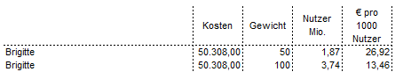  If the media weight is set to 50, then the reach is reduced by 50% and the cost per 1000 users doubles.
Media exposure/advertisement exposure | The following describes the characteristics for exposure.  If the questionnaire contains advertisement exposures (AEs), then an additional folder is shown with selectable characteristics. Advertisement exposure characteristics are calculated in the same way as media exposure characteristics.
Users % | Net reach in %
Users m. | Sum total of persons reached by the media unit with the specified number of bookings selected. The net reach is calculated by determining one person's likelihood of exposure with an average issue/broadcast (e.g. LpA). For a single booking, this is defined as the weighted total of likelihoods for all persons in the target group. For multiple bookings, the internal overlaps are factored in and then eliminated.
Users resp. | Net reach in resp.
Cost per 1000 users | 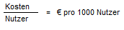  Also: Cost per Thousand (CPT). Specifies the sum required to be deployed for an advertising campaign in order to reach 1,000 individuals in a target group.  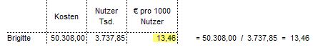
Affinity | The affinity equates to the index in the Tabulation: the proportion of the readers in the current target group (i.e. the net reach) is compared with the proportion of the readers in a comparative target group.
Affinity Total | While the plan value affinity is calculated for the current reference target group, "Affinity Total" always applies to the overall target group.
Compos. % | The readership of the current target group is calculated as a percentage of the readership of the comparative group. The composition can therefore be used to analyse the structure of the readership. Example: "Brigitte", target group "Women", comparative target group "Overall", composition 95.1%, i.e. women make up 95.1% of the readership.
Circu. weighted by target grp.
Circu. weighted by CPU | 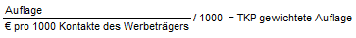  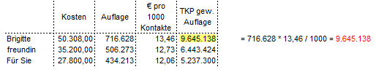
GRP | (Gross Rating Point). Gross reach in %. Summed figure for exposures without considering overlaps, specified as a percentage value.
Exposures m. | Total exposures, i.e. the number of all exposures that are achieved by the number of bookings of the media unit.  Exposure total = net reach x average number of exposures.  For multiple bookings of a medium or multiple media, the individual reach figures are totalled, without taking into account internal and external overlaps.
Exposures resp. | Gross reach in cases
Average exposures | Average exposures = average number of exposures that the media audience has with the media unit. Exposure total / net reach
Cost per 1000 users | 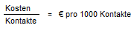  Also: Cost per Thousand Users (CPU). Specifies the sum required to be deployed for an advertising campaign in order to reach 1000 exposures in a target group.  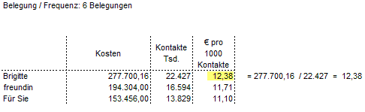
Indexes | In each case, the basis for calculating the index is the best medium for the respective datapoint
Index Users % | Basis for calculating the index is the medium with the greatest net reach.  The best medium receives an index value of 100; the lower the reach, the lower the index value.  The index is calculated as a ratio:  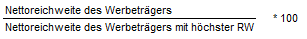  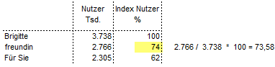
Index CPT | Basis for calculating the index is the medium with the lowest Cost per Thousand (€ per thousand users).  The medium with the cheapest Cost per Thousand receives the value of 100. As CPT increases, the index value drops.  The index is calculated as a ratio:  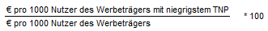  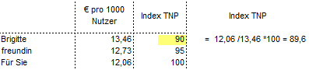
Index Affinity | The basis is the medium with the highest affinity; calculated as for Index Users.
Index Compos. | The basis is the medium with the highest user composition; calculated as for Index Users.
Index Circu. weighted by Circulation | The basis is the medium with the highest circulation weighted by target group; calculated as for Index Users.
Index GRP | The basis is the medium with the highest exposure figure; calculated as for Index Users.
Index CPU | The basis is the medium with the lowest Cost per Thousand Users. Calculated as for Index CPT.
Total index | The individual indexes reported in the ranking are consolidated into an overall figure.  Total of indexes: all indexes reported in the ranking are summed together.  Average of indexes: Total of indexes/number of indexes  Example: "Fernsehwoche" Average of indexes = Index CPT + Index Users % / 2 36 + 32 / 2 = 34  Indexes total = Index CPT + Index Users % 36 + 32 = 68
Ranking | Ranking position #1 is given to the best medium for each datapoint.  The positions are awarded in ascending order. Position #1 is given to the medium with the greatest net reach (ranking Users %), the best-value Cost per thousand (ranking CPT), etc.

Sorting the ranking

You can sort the table in ascending or descending order by clicking the arrow in the column header above the plan value.

Displaying results in millions/thousands

The display of characteristics in m. is changed globally to show figures in thou. by clicking the icon in the target group row. All characteristic values are automatically converted. ("Users m." becomes "Users thou.")

Batch ranking counts

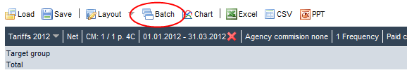

First, define a media list and sort the ranking by your chosen characteristic.
If you click the Batch menu item on the toolbar, then an extra area is shown next to the ranking.
You can now drag individual target groups or complete attributes into this area – either directly from the Codesheet or from the folders "Own structures", "Own target groups", "Temporary target groups".
The target groups in the batch structure are edited in the same way as the rows in the Tabulation: combinations of target groups can be easily created in this structure.
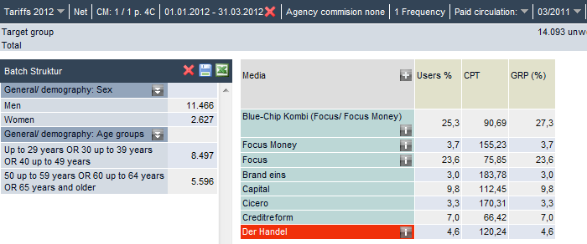.
In the example above, 4 rankings are calculated for the target groups "Men", "Women", "Persons aged 49 and under" and "Persons aged 50 and above".
The results are output via the Excel icon in the Batch Structure row.
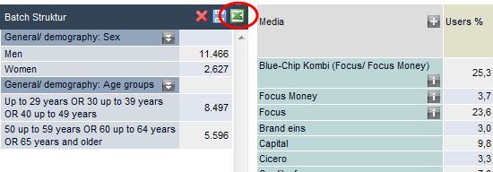

Click the Table icon on the toolbar to exit from Batch Mode.

Media plan
The exact same media selection is utilised in the media plan analysis and the ranking counts. The media from the ranking are applied as plan candidates – incl. media-specific presets – to the media plan analysis. This also means that a medium with an active issue is removed from the media plan if it is deleted from the ranking.

Assigning a plan

The general rules for plan calculation – such as the tariff selection, format and circulation file – are defined in the header rows of the workspace.
All of the media presets that you have made in the ranking are applied to the media plan definition.

Select all potential plan candidates from the Media folder and use drag-and-drop to move these to the field highlighted in green under "Media".
The icon in the Media field is used to access all of the discount combinations formed by the media items selected. The combos are applied to the media selection by clicking.

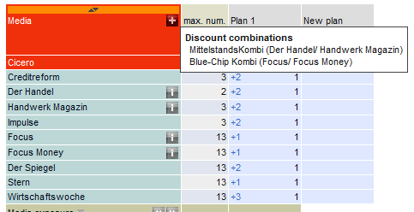

1. Direct entry of frequency on the plan screen
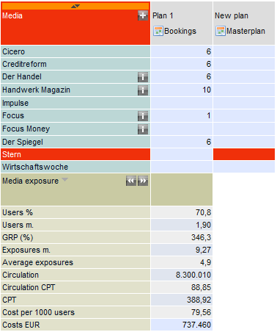

For improved usability, the medium and input position (here: "Hörzu" / Plan 1) are highlighted in colour.
Input is deleted using the [Del] key.

2. Assigning a plan using the plan header context menu

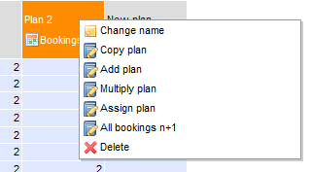

Change name | The name of a plan can be changed.
Copy plan | After accessing this menu item, a small input box is shown in the current plan column. In this box, enter the number of the plan that is to be copied across the current plan column.
Add plan | The bookings of a different plan are added to the bookings of the selected plan. After accessing "Add plan", an input box is shown into which the number of the plan to add is entered.
Multiply plan | The current plan is multiplied by the figure that you enter.
Assign plan | All media are given the same number of bookings. Move to an empty column and select the menu option "Assign plan". In the input box, enter the intended number of bookings per plan candidate.
All bookings n+1 | The bookings of an existing plan are increased by the specified number.

Ranking columns with editable media information are applied from the ranking and positioned in front of the plans. These values can also be inserted before the plan alternatives directly from the Characteristics folder.
The results of the plan calculation are displayed immediately below the media list and updated with each new booking. If a plan contains a media booking without a price, then cost-related characteristics cannot be calculated.
You can use the Save icon on the toolbar to save all of the plan definitions into a file.

The context menu on the Media field offers the following operations:

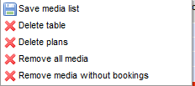 | - Media are saved with presets configured by the user  - Media and plans are deleted  - Plans are deleted, media list is retained as-is  - All media are deleted  - Media with no bookings are deleted from the media list

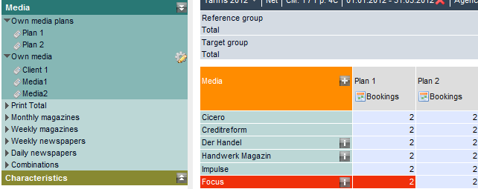

Plans are temporarily stored for further use in segmentation under the item Own media plans in the Media folder.
Saved media lists are stored under Own media in the Media folder.

Selecting characteristics

Characteristics folder

The datapoints listed in the Characteristics folder can be inserted into the media plan table for the purposes of documenting and editing the media parameters of individual booking items.
If you drop your chosen characteristic onto the table head, it is inserted into the plan overview in front of the first plan. Media presets made here are applied to the ranking.

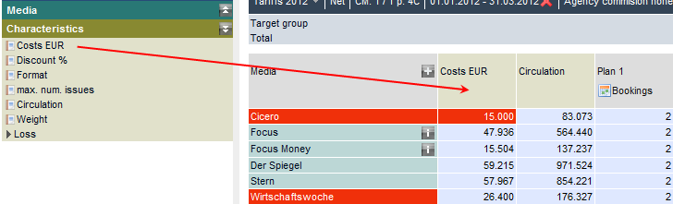

In the media plan, circulation is selected using the drop-down menu:

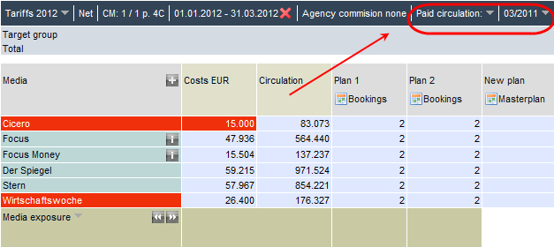
Selecting circulation type and quarter in the media plan

The Layout menu item on the toolbar is used to specify the characteristics for displaying the results.

Loss in Plan 1: exclusive contribution of a medium to the overall plan
The loss characteristics specify, per medium, the reduction to the overall plan resulting from the removal of a medium from the plan. This is the exclusive contribution made by the medium to the overall plan.
The total of individual figures for net reach does not equate to the reach of the overall plan, since duplicate audience figures are considered. The calculation is always applied to the 1st plan in the plan view.

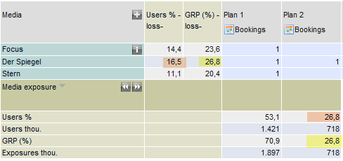
Loss in Plan 1

The exclusive contribution of the magazine "Spiegel" to the net reach of the plan is a net reach of 16.5%.
The difference of 256.8% net reach achieved when booking "Spiegel" to the 16.5% loss figure in the plan results from the fact that "Spiegel" readers also read one of the two other media (duplicate audience).

Layout of media plan reports

On the reporting page, you can use the drop-down menu on the right of the "Layout" button to access the list of your stored profiles, in order to change the table layout. When the program starts, the table layout defined as Standard is loaded.
In the Layout – Media plan window, you specify your desired analysis values. These presets apply equally to both media exposure likelihoods and advertisement exposure likelihoods. Enter the number of significant figures on the "Digits" line.

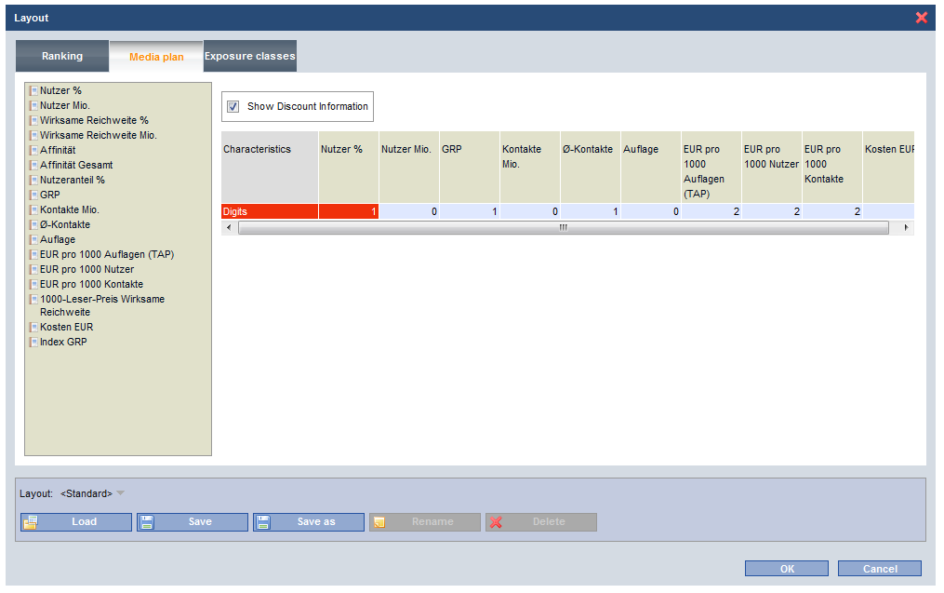
Media plan layout screen

Displaying discount level

Discount information can be read at any time during the planning process.

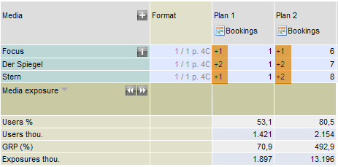
The blue number specifies how many additional bookings are necessary to reach the next discount level (volume pricing is factored in).

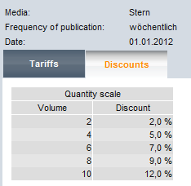 | Example – "Stern":  With 1 booking, 1 extra placement is needed for the next discount class, while 2 are needed with 8 bookings.
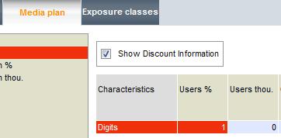 |  | On the media plan layout screen, the display can be deactivated using the option "Show Discount Information".

Defining exposure classes
Up to 36 exposure classes can be defined for calculating exposure distribution in the media plan analysis.
The Allocate button can be used to set the Steps and the Upper bound. The upper bounds can also be entered directly (and deleted) in the window. Exposure classes are automatically adjusted to any changes in upper bounds.

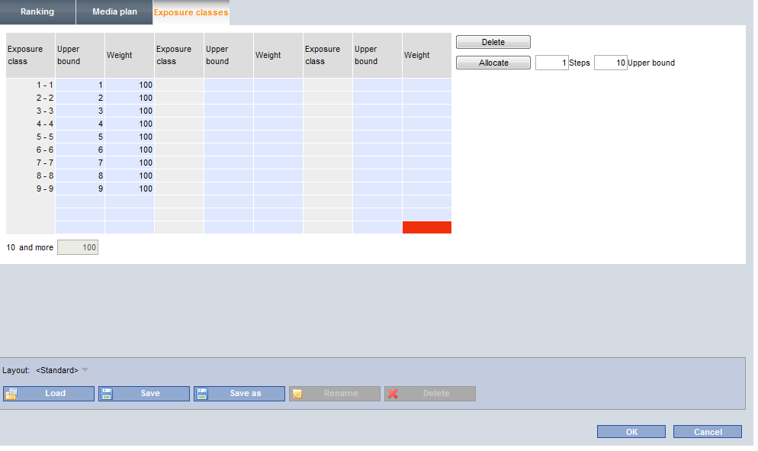
Defining exposure classes
The definition of weightings for the efficacy curve is made on this screen. In contrast to the calculation of normal reach, the calculation of effective reach takes into account the evaluation of exposures. If you set the weightings for Class 1 to 6 exposures to 0, for example, then the calculation of effective reach will include only those persons who report 7 or more exposures with the media of the media list.

Price optimisation on/off

Price optimisation: on
M-Cloud calculates the costs while taking potential combo discounts into account.
Example: Blue-Chip combo

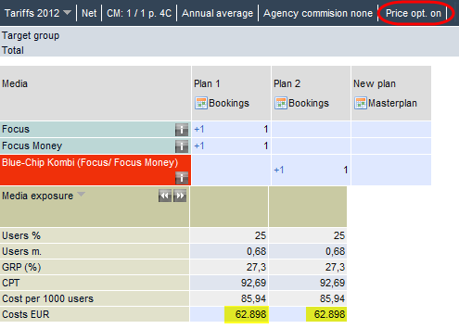

The media combination (Plan 1) defined via the single media has the same price as the "Blue-Chip" combo (Plan 2).

Price optimisation: off
Without taking into consideration the possible discounts that result from the combo discounts, the costs for the user-defined combo are higher.

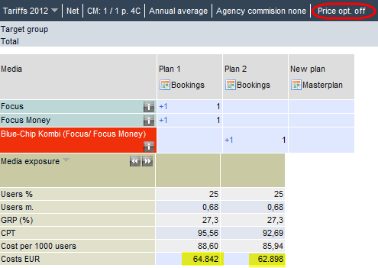

Masterplan – automatic plan optimisation

The masterplan feature is used to automatically generate an optimum booking plan for freely-definable target groups.

The algorithm uses the permutations of media and frequencies to calculate the best solution for the plan targets of reach, plan costs or exposure range.

The optimum plan is found when one of these goals has been achieved.

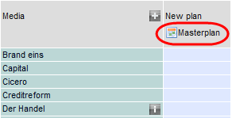

Plan optimisation considers time slices for digital media and single issues for the print sector. Media items without pricing information are automatically excluded from plan optimisation.
Following the selection of media as potential plan candidates, the following optimisation settings can be made:

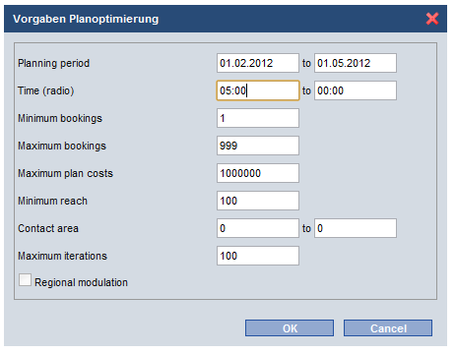

Planning period
Planning period values are used to calculate the maximum number of bookings for each medium in the selection.

Time (radio) from/to
For plans with radio bookings, an option is provided for you to define a time slot.

Minimum/maximum bookings
Here, you can preconfigure the required minimum/maximum bookings for all media contained in the plan.

Maximum plan costs
Enter the available budget.

Exposure range from/to
Set the desired exposure dosage

Regional modulation (radio)
For national counts, the regional modulation ensures a uniform distribution of GRPs throughout Germany's federal states. The precondition here is a national target group and a national broadcaster selection.

Examples of optimisation goals
- Reach (e.g. 70%): Set costs to maximum and do not define an exposure category.
- Costs (e.g. € 3,000,000.00) Set reach to 100%, do not define an exposure range.
- Exposures (e.g. min. 10 exposures): Set reach to 100% and set costs to maximum.

The Optimal plan is displayed in the first row of the table.

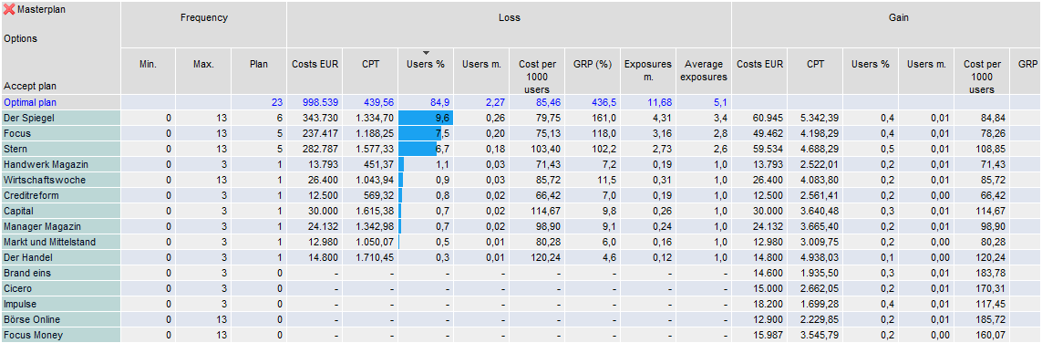

The "Loss" column specifies the amount contributed by each medium. If the medium "Spiegel" were to be removed from the plan, for example, then the plan's reach would drop by 9.6%.
The "Gain" column indicates the gain that would be achieved by another placement of medium x for the "Optimal plan".
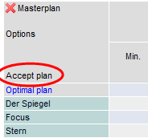 | The plan can be accepted as a new plan for the media plan list by selecting "Accept plan".

The time dimension

In the media plan analysis, it is now possible to plan the bookings of media for a campaign using a calendar-based interface.
Using the "Placements" icon at the head of the plan, you can access a calendar sheet on which you can enter the bookings.
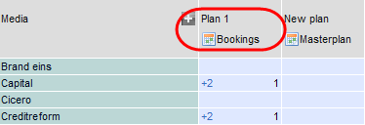

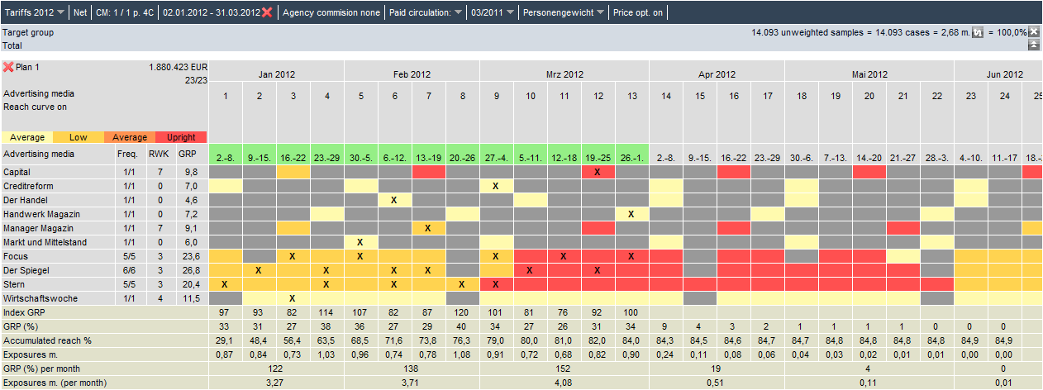

Table head – information and presets
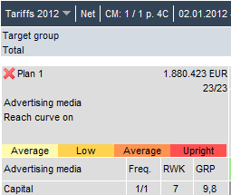 | In the table head, the plan costs and the count of already assigned placements are both displayed  Click "Advertising media" to switch to the plan view "Advertisements"  Reach curve on  This takes into account the fact that for magazines, the reach of a placement does not occur instantly on the day the issue appears and is not limited to this one day.  The "Time dimension" evaluation has analysed the reach structure of magazines and determined differences dependent on magazine type. Following this, the magazines analysed are assigned to one of 7 groups with a similar reach structure.

Example: One booking for "ADAC Motorwelt" (monthly medium)
With one booking on March 15, the issue acquires exposures and reach up until May.

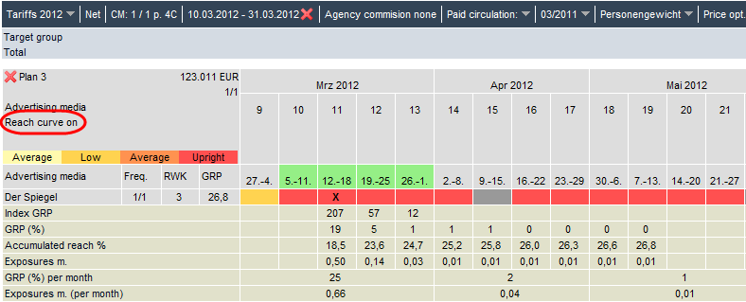

Reach curve off
The exposure structure curve typical for the type is not considered. The entire reach is assigned to the relevant week the issue appears.
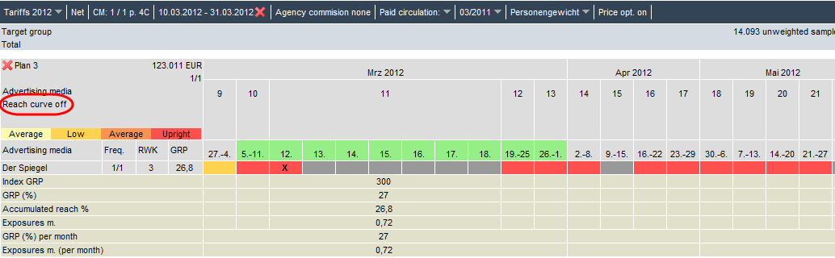

Back to the media plan view
Close the plan's calendar view by clicking the cross on the left of the table head.

On the calendar sheet, the publication dates are documented in colour to show price zone information:
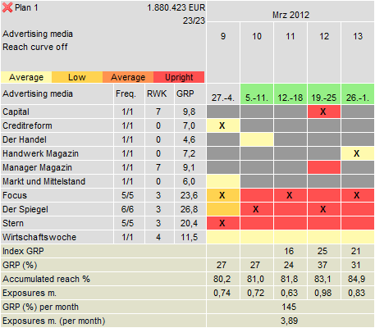

Red | High price
Orange | Medium prices
Amber | Low prices
Light yellow | Annual average prices/fixed price
Grey | No information on publication type or no magazines/weekly newspapers
Information per medium
Freq. | Count of issued/planned bookings
RWK | Assignment of the medium to one of the 7 reach curves
GRP | Gross reach of the medium for one booking

Click the calendar week number to switch between a weekly and a daily view.
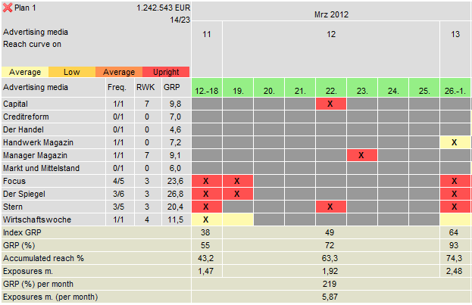
Per-day view of calendar week 12

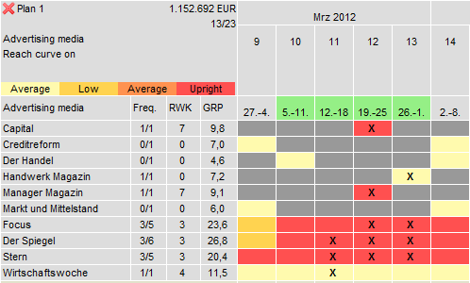
Per-week view of campaign period, wks. 10–13

Spreading bookings
Individual placements can be spread either manually by clicking on the fields in question or automatically.
If you right-click the header row, a menu appears with which you can then trigger the automated spreading of bookings over the campaign period by selecting "Spread bookings through time period".
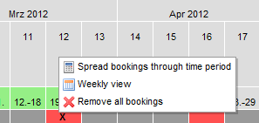

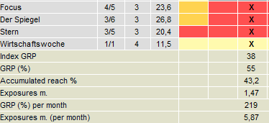

In the lower section of this window, the spread of the print medium is documented using a calendar view.

Index GRP | The index is calculated from the plan's exposures attained in relation to the number of weeks in the campaign period.
GRP (%) | Gross reach in % per week  (In which week is the greatest gross reach achieved?)
Accumulated reach % | The overall reach is achieved with the last booking  (From which week is the increase in reach no longer relevant?)
GRP (%) per month | Segmentation of the overall gross reach achieved on a monthly basis
Exposures m. (per month) | Segmentation of the overall exposures achieved on a monthly basis

Plan analysis

The Layout menu item on the toolbar is used to specify the characteristics for displaying the results.
The result is updated with every change made to plan presets, i.e. if bookings are changed or another format is selected for individual booking units, then the result can be read off immediately.
By default, media exposure results are shown. This is indicated in the heading of the results table.
By using the drop-down menu next to Media exposure, you can switch to viewing the results overview for Advertisement exposure.
The display of the characteristics "Projected users" / "Projected exposures" is synchronised with the display of the filter target group. If you change the display from "m." to "thou." for the filter target group, the display of the plan results is adjusted accordingly.

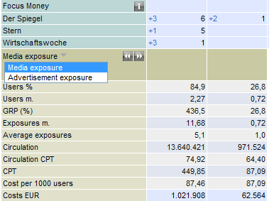

By clicking the icon in the results row, you switch to the exposure distribution of the defined plans.

Effective reach
To calculate the effective reach, the reach portion from the lower range of distribution is subtracted from the overall reach of a media plan. For example: if the overall cumulated reach for a plan is 59.8% and at least 3 exposures are required to attain the advertising goal, then one must subtract each reach portion that contains only one or two exposures from the overall reach.
This is achieved by setting the weighting for exposure classes 1 to 2 to zero on the exposure classes layout.

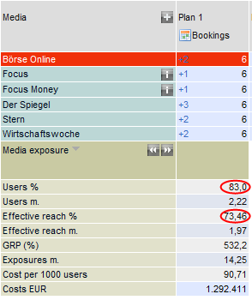 | 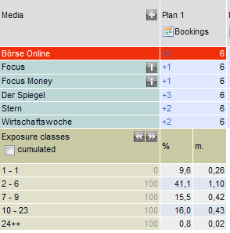

The effective reach equates to the net reach if all exposure classes are calculated with a weighting of 100.

Exposure distribution

The table shows the distribution of users over the individual exposure classes. You can also switch to a cumulated view of the exposures.
The Layout menu item on the toolbar is used to configure the exposure class definitions.

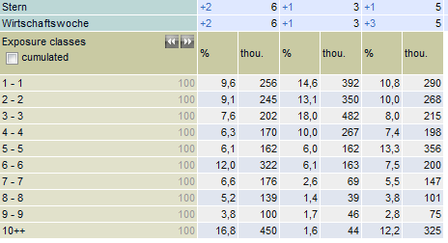

MediaMix

If a plan contains a variety of media types, then the option "MediaMix" is shown.
Calculations are made to show the person who are reached mostly or exclusively via print media and via digital media, or who are reached equally well by both types of media.
The icons and in the "MediaMix" row can be used to display the results either as a graphic or in tabulated form.

A person is assigned to the "Print" group if at least 80% of this person's overall exposures to the plan have been collected via print media. Similarly, persons are assigned to the "TV" group if at least 80% of the exposures have been achieved using digital media.
The remaining persons are assigned to the "Mix" group.

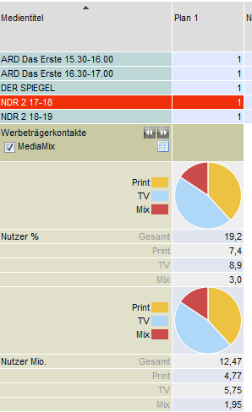 | 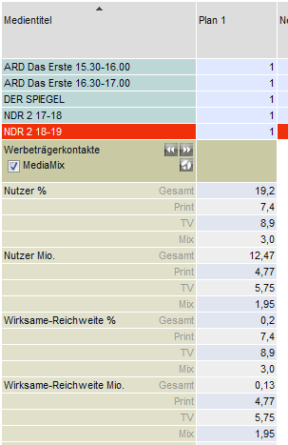

Segmentation

The segmentation of the plan results is calculated using the Tabulation report module.
Drag one or more plans from the temporary folder Media – Own media plans into the table – and into the table head or the table rows, depending on the type of report you want.
The Layout Table menu item on the toolbar is used to specify the characteristics for the segmentation table.

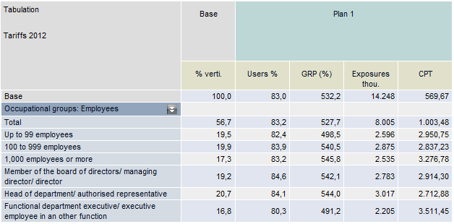

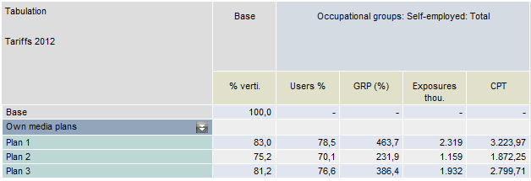

Charts: producing graphical reports
Select the table cells that are to be displayed as a graphic. The graphics window is accessed using the Chart button on the toolbar.

The Chart screen limits the number of entries on the X-axis to a maximum of 10. If more than 10 entries are present, navigation icons are shown on the lower edge of the screen for paging backwards and forwards.

If no table section has been marked before accessing the Chart screen, then the first 10 rows and the first 5 columns are made available for creating charts in this window. A corresponding message is also output: "Number of rows reduced to 10. Number of columns reduced to 5."

If the base column is not explicitly marked in the table for graphical display, then it will accordingly not be provided for the creation of charts.

The initial graphic is created using the pre-column marked: all other selected columns are then made available in the "Series" field for inclusion in the graphic. Click the colour field to access the colour selection for the attribute.
The results can be represented using a line, column, bar or pie chart.
The graphic is output via the "Excel" button as an editable chart: the chart itself is embedded on the "Chart" worksheet and the report is included on the "Data" worksheet.

Example: Creating a chart without marking

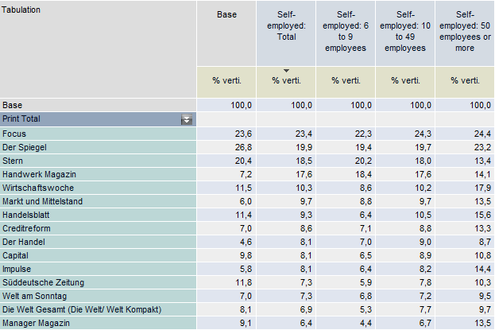

The first 10 rows and the first 5 columns are made available for creating charts in the window.

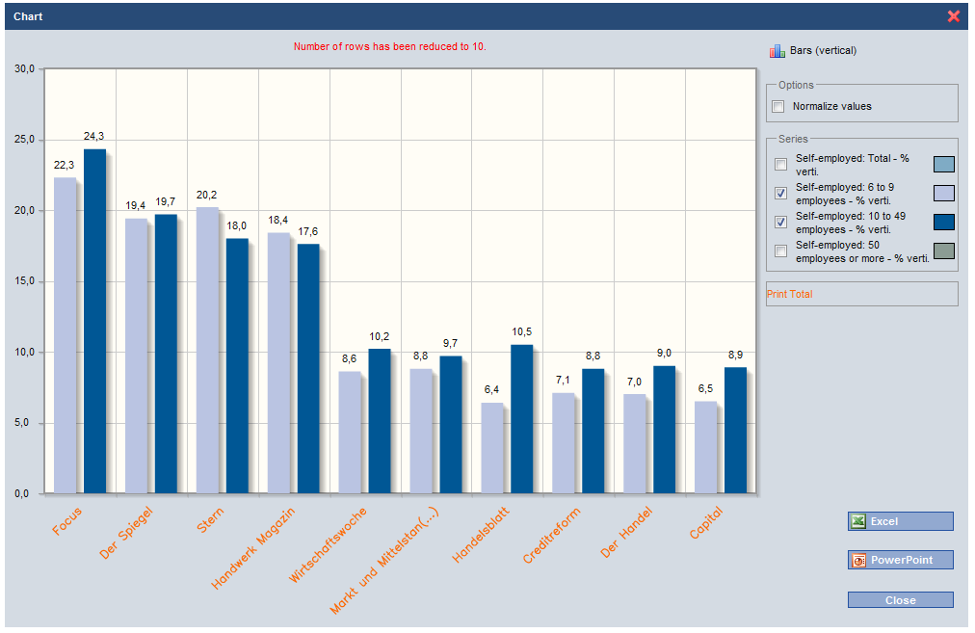

The default behaviour is to skip the base column.
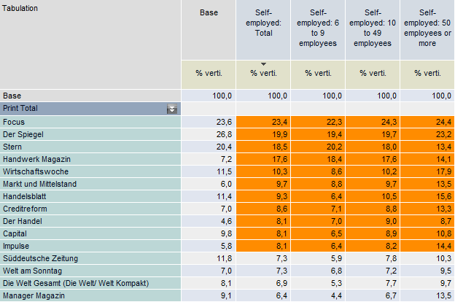
Example: Creating a chart from a range of marked columns
Here, the base column can be displayed on the chart.

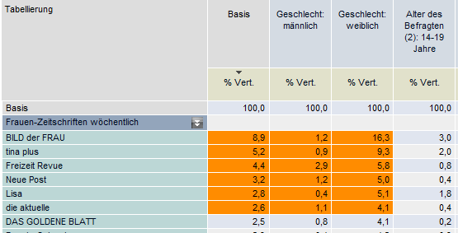

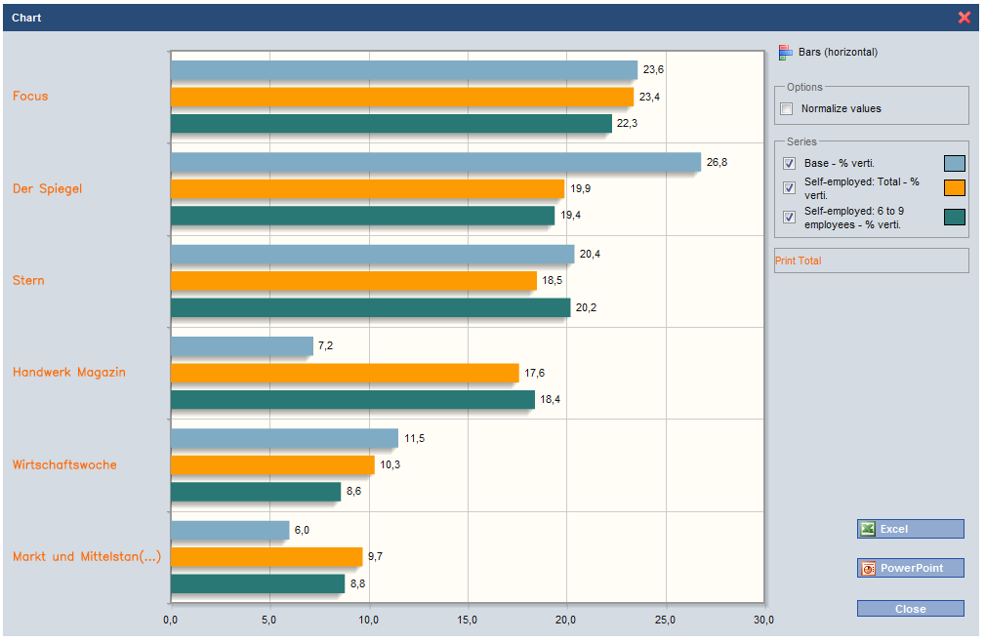

Normalising value range
If characteristics containing different value ranges are to be presented on a single chart, then this option can be used to normalise the scaling of the characteristics across the x- and y-axes.
Without normalisation, the graph for "Exposures in m." will be shown to the scale of "EUR per 1000 Exposures".

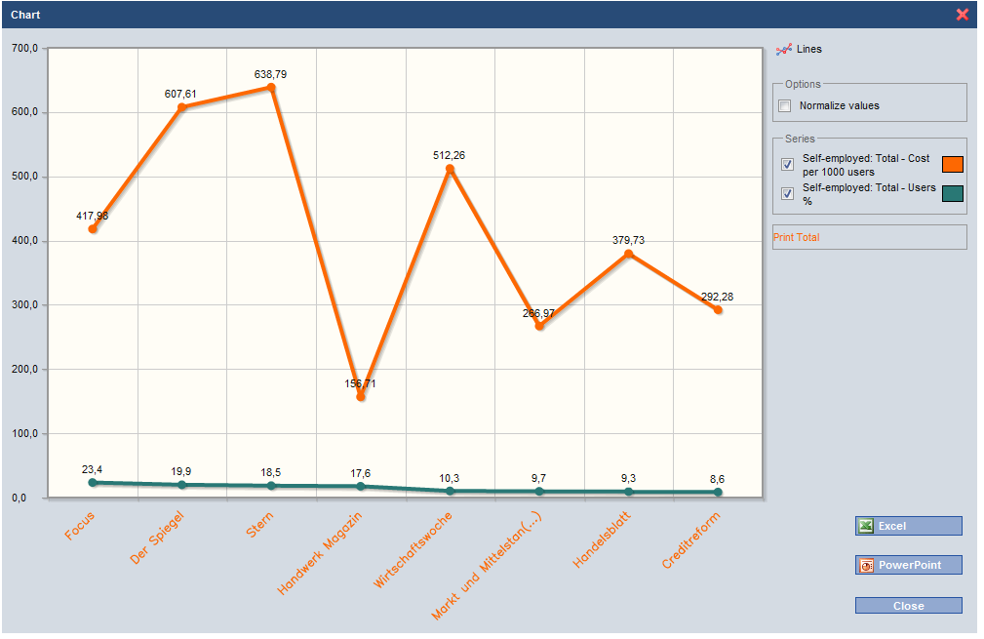

If the "Normalise values" option is checked, then each column is scaled individually on the chart.
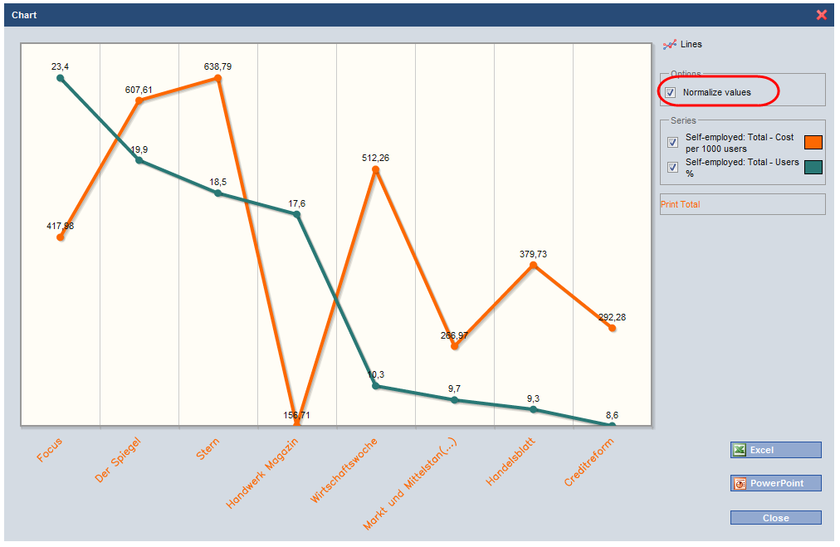

Target group
The Target group menu option is intended for the creation of complex target group definitions, since simple target groups in the Ranking, Media Plan and Tabulation modules cannot be inserted directly from the Codesheet into the report.
The target groups defined here are automatically made available for all reports in the Codesheet's Temporary target groups folder.
On the left part of the screen, the Codesheet is shown with all attributes for the selected questionnaire. The status bar displays the name of the current questionnaire.

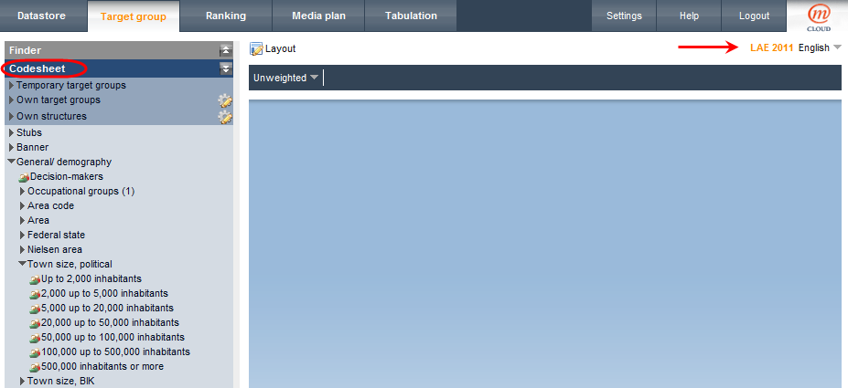

You drag your target group directly from the questionnaire's Codesheet and drop it onto the workspace. The potential is shown immediately; with linked target groups, the potential of the overall target group and each partial target group is shown.

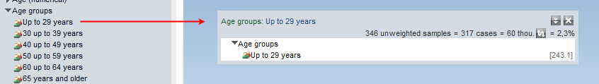

The target group is presented as a box, consisting of a header row and a definition area.
By double-clicking the title of the target group, you can load it into any report as a filter target group.

The target group box

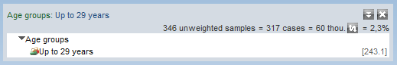

If you drag an individual target group onto the workspace, then the text of the selected codepoint is applied to the header row. In addition, the potential of this target group is also shown. The presentation of the target group data is specified using the Layout menu item.
The icon can be used to switch between the display format "Projection in thou." and the display format "in m.".
For each partial target group, the right-hand edge of the target group window lists the column and code in accordance with the questionnaire's codesheet.

All of the usual target group editing options such as Save and Delete can be selected from the right-click context menu.
To open the menu, right-click the target group's header row.
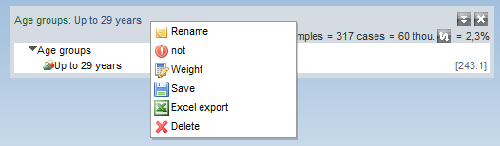

Renaming
The target group text can be altered using an editing window.
Simply changing the text of the target group's descriptions does not affect the target group selection.

The NOT operator
The NOT operator can be used to define the complementary quantity for a target group.

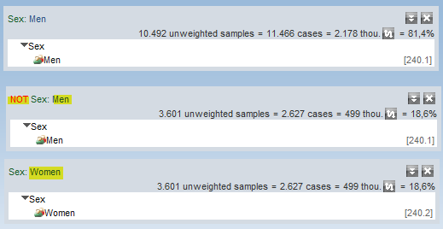

Example: The target group "NOT Men" equates to the target group "Women".

The AND NOT operator has been replaced by the NOT operator.

Example: Men without a university degree.
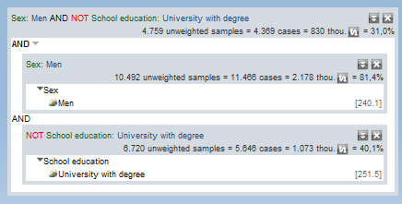

- Select "Men"
- Select "University degree"
- Negate the target group "University degree"
- Enclose both target groups with a box
- Change operator to "AND"

Weight
Target group weighting makes it possible to reduce the influence of specific groups of people for a count, if this group of people is of less interest for the report currently under consideration. By default, the weight is set at 100 for all attributes (groups of persons).
Changes influence all counts performed subsequently (tabulations, rankings, media plan analyses).
If you right-click the structural attribute to be weighted, you can select the weight from the menu and set it to a new value.

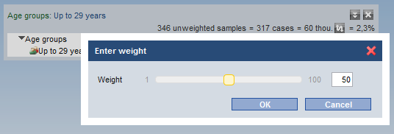

Example: Target group weighting
For the report on media reach for the "Motorpresse" magazine, the reach for women is to be considered only to 50%.

The 3rd target group considers all men (11,466 cases) and women at 50% (1,314 cases)
In contrast to the "normally" weighted 1st target group of Men or women (14,093 cases), the weighted 3rd target group has removed half of the women's cases: 14,093 – 1,314 = 12,779 cases
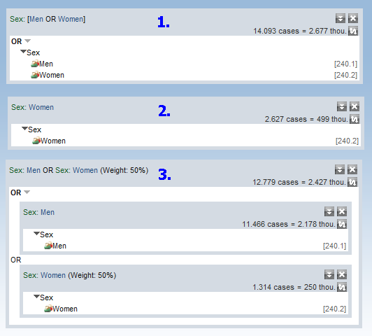
The attribute weightings can be applied to any available target group.

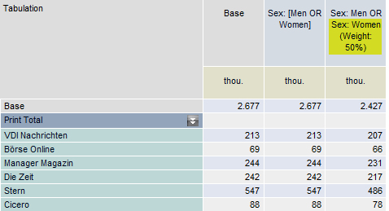

Combined target groups
Combined target groups are presented as nested target group boxes.

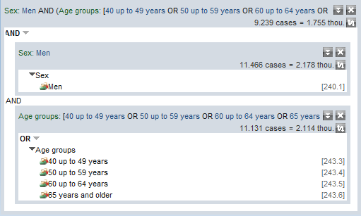
Target group: "Men aged 40 and over"

Each target group box is assigned a link logic that specifies the operator that has been used to link the entries listed in the box.
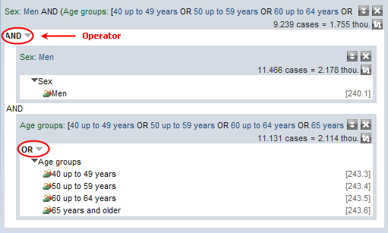

Operators | Examples
AND | "Men" AND also "Aged 30-39"  AND always limits selections,  i.e. the target group size is SMALLER or the same as the single target groups.
OR | People aged 14-20 OR (i.e. also) people aged 20-29  OR always expands a selection,  i.e. the linked target group is LARGER than one of the partial target groups.
X from Y | Target group that matches the specified number of attributes.  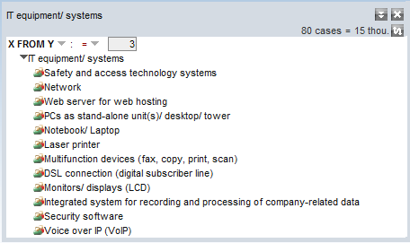  The potential target group includes all respondents for whom two or more of the selected attributes apply (at least 3 of 12 appliances)  You can use this operator to specific core target groups.
EITHER-OR | Persons who either drink ONLY red wine or drink ONLY white wine.  This gives you a target group that is characterised by exclusive attributes.

Creating combined target groups
On the Codesheet, select your chosen single target groups and use the mouse to drag these over to the workspace. Both single entries and complete attributes can be drag-and-dropped to the workspace. The target group is displayed as a nested box.
The names of all the target groups and the linking operators are copied and displayed in the header row of the combined target group.
If the Group entries option is selected on the Layout (as is the default), the following applies:
- A single attribute's codepoints are linked using "OR"
- Codepoints that belong to different attributes/questions are linked using AND

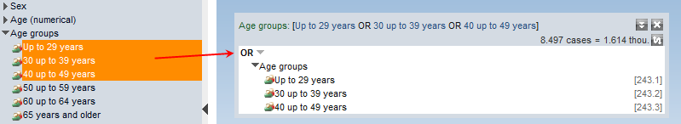

Automatic linking within an attribute using OR

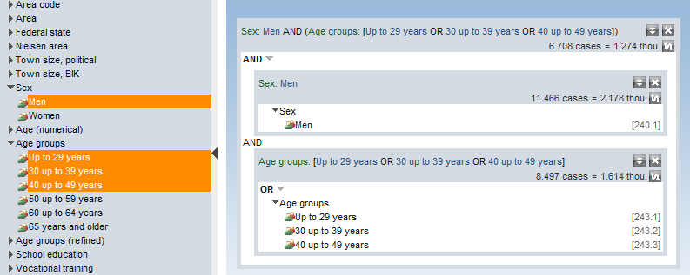

Automatic linking within an attribute using OR, between two different attributes with AND

The target group potential and target group label are updated with each change made to the target group.
If you right-click with the mouse, a window opens for editing the text.
Other target groups from the Codesheet can be attached to existing target groups at any time via drag-and-drop. Alternatively, pre-existing entries in the box can be deleted from the same right-click menu.

Combining multiple target group boxes
Complex target groups can be created by combining multiple target group boxes.

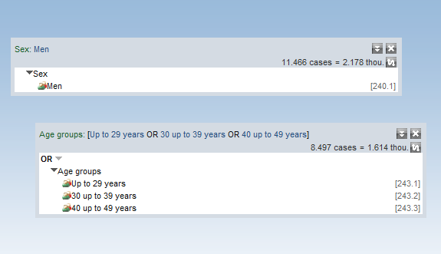 | Step 1  The target groups that are to be combined into a new target group are dragged from the Codesheet to the workspace.
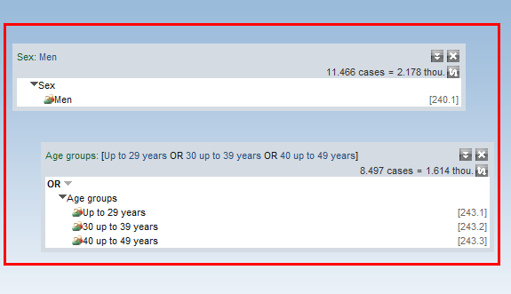 | Step 2  Left-click with the mouse and drag a box around the target groups to be linked.
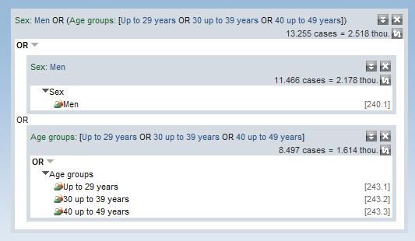 | Step 3  When you release the mouse button, the framed target groups are combined into a new target group by the "OR" operator.  If necessary, you can now change the link operator.

Target group layout
The Layout menu item is used to open the window for specifying the target group layout. The presentation shown here applies for filter target groups on the Tabulation, Ranking and Media plan screens.

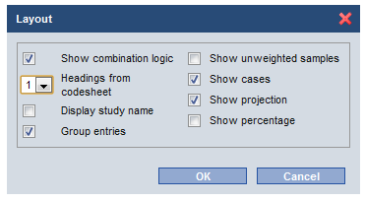

Show combination logic
The operator within a target group box can be shown or hidden.
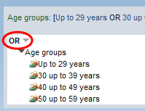

Headings from Codesheet
The number of headings that are to be used for the target group description can be specified for each individual target group.
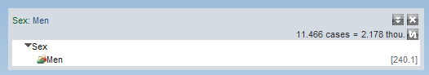
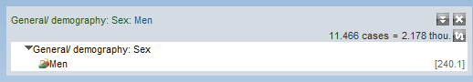

In the example above, one heading has been selected and two in the lower example.
Group entries
This option should be used as standard, to ensure that the automatic linking logic is applied, i.e.
A single attribute's codepoints are linked with "OR"; codepoints from different attributes are linked with "AND".
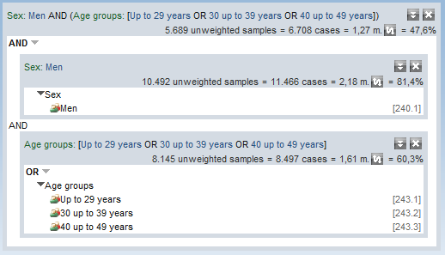

In the example above, the partial target groups have been linked sensibly: the age groups using "OR" and the target groups age and sex with "AND".

If the option is not selected, then all partial target groups are linked using the "OR" operator.

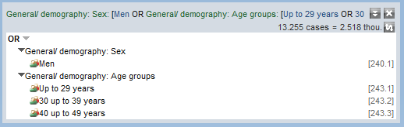

Potential units of measure
The selection made here applies to the presentation of the base target group for tabulation, ranking and media plan filters.
The projection unit of measure is specified in each case in the report features: the icon can be used to switch between showing the projected total in thousands or millions.

The units of measure for the presentation of the filter target group can be changed only via the layout option from the "Target group" tab page.

Numerical values
Individual questions such as net household income can be stored numerically in a dataset.
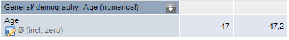
The icon means that the value displayed has been calculated as an average of all entries. Independently of the presentation selected, the value is always shown in the currency of the variables, i.e. income in EUR, age in years, etc.
By clicking the icon, a selection window opens with a range of available options.
Selecting Range gives you a freely-definable value range, e.g. "Age between 15 and 23 years".
The Gross option means all values of this attribute will be summed.

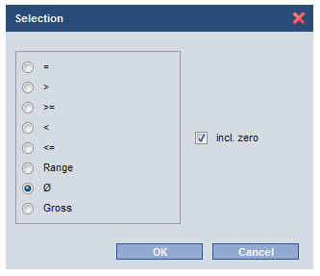

The reach of a media unit (LpA, listener for a time slot) is a specialised numeric field. For more details, see Media in the Tabulation

Index
A
Circulation 32
Segmentation 67
Selecting characteristics 37, 50
B
Editing media-related presets 36
C
Codesheet 3
D
Displaying results in millions/thousands 46
Definition of media combinations for any media item in a type 36
The time dimension 57
E
Own media – saving media lists 36
Excel – CSV 10
F
Finder 2
G
Generator 25
Basic conditions for media 29
K
Exposure distribution 65
L
Loading and saving 7
Layout 9
Layout of media plan reports 52
Characteristics 5
M
Selecting and deleting 6
Masterplan – automatic plan optimisation 55
MediaMix 66
Media 4
Media in the Tabulation 16
Media selection 35
Counting media overlaps 23
Language selection 5
O
"Characteristics" folder 50
P
Assign plan 47
Plan analysis 63
Price optimisation on/off 53
R
Batch ranking counts 46
Changing the order of table columns/table rows 11
S
Sorting the ranking 45
Sorting columns 13
StoryFinder 27
T
Table filters 12
Table layout 17
Tariffs 30
V
Linked target groups 13
Z
Time series 26
Target group 34
Changing the target group name 15

